1. Download eclipse from <http://www.eclipse.org/downloads/download.php?file=/technology/epp/downloads/release/kepler/SR2/eclipse-jee-kepler-SR2-win32-x86_64.zip>

C:\Users\IBM_ADMIN\AppData\Roaming\Tencent\Users\1095570977\QQ\WinTemp\RichOle\JCJBL{%QCEN(TV4ZPD}1MYF.jpg

1. Unzip eclipse-jee-kepler-SR2-win32-x86\_64.zip

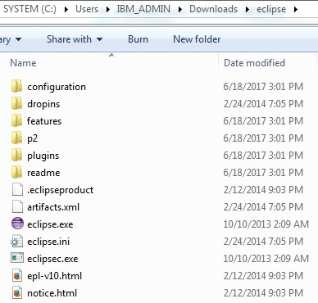

1. Run Eclipse and Create Dynamic Web Project

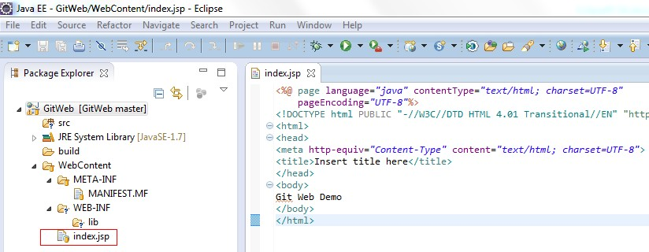

1. Create repository GitWeb in github

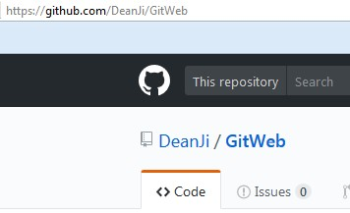

1. Right click GitWeb from Eclipse 🡪 Team 🡪 Commit to local repository
2. Right click GitWeb from Eclipse 🡪 Team 🡪 Push to remote repository(github)

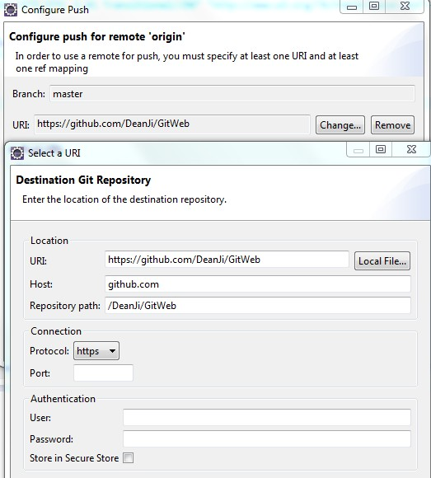

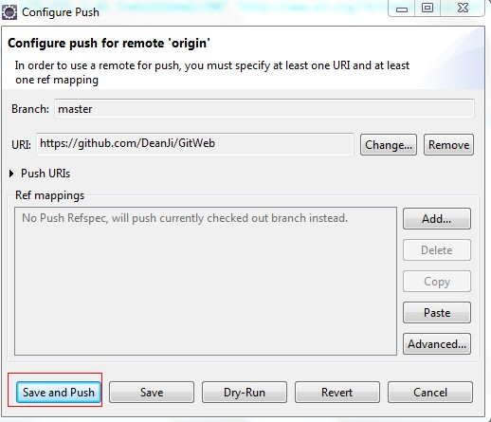

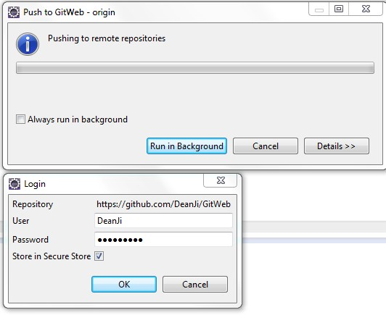

1. Push fails due to “non-fast-forward” errors
2. Pull from remote repository first, right click GitWeb 🡪 Team 🡪 Pull
3. Push again

